[Title]

[Author]

[Institution]

Author Note

[Grant/funding info and complete correspondence address.]

**A LIBRARY DATABASE SYSTEM**

**Task(2): DESCRIPTION OF SYSTEM**

**data independence**

Data Independence is defined as a property of DBMS that helps you to change the library Database schema at one level of a database system without requiring to change the schema at the next higher level. Data independence helps you to keep data separated from all programs that make use of it You can use this stored data for computing and presentation. In many systems, data independence is an essential function for components of the library system.

Problem: library system may have data redundancy because of data independence

**data consistency**

Data consistency is the process of keeping information uniform in a library system as it moves across a network and between various applications on a computer. There are typically three types of data consistency: point in time consistency to save the data loss in power in Library and application consistency database application works well in the Library Ensuring that a computer network has all elements of data consistency covered is the best way to ensure that data of Library is not lost or corrupted as it travels throughout the system. In the absence of data consistency, there are no guarantees that any piece of information on the system is uniform across the breadth of the computer network in a library.

Problem: data may be hard to add or make a backup and run the database of the library or add new data in the database

**data integrity**

## Data integrity is the overall accuracy, completeness, and consistency of data. Data integrity also refers to the safety of data in regard to regulatory compliance and security. It is maintained by a collection of processes, rules, and standards implemented during the design of the Library system phase.

## Problem: bad process to maintain or bad rules or bad design

## Types of data integrity

Maintaining data integrity requires an understanding of the two types of data integrity: physical integrity and logical integrity. Both are collections of processes and methods that enforce data integrity in both hierarchical and relational databases.

### **Physical integrity**

Physical integrity is the protection of the wholeness and accuracy of that data in the library system as it’s stored and retrieved. When natural disasters strike, power goes out, or hackers disrupt database functions, physical integrity is compromised. Human error, storage erosion, and a host of other issues can also make it impossible for data processing managers.

**data security**

Database security refers to the various measures organizations take to ensure their databases are protected from internal and external threats. Database security includes protecting the database itself, the data it contains, its database management system, and the various applications that access it

Eg. Students cant use the library database to take books

Problem: hacker can get in and erase the data of 100 or 1000 books

**the scale of data sharing.**

Sharing the full data sets underlying the results in your article brings many benefits. It enables reuse, reduces research waste, and promotes collaboration. Greater transparency increases trust in research results by allowing results to be independently verified. These benefits lead to a more reliable evidence base and a healthier world.

Example

One campus can use other campus data to see or take books that are used and will be useful to them

Problem: must be shared on a small scale otherwise it will make an issue

**data redundancy**

Data redundancy is a condition created within a database or data storage technology in which the same piece of data is held in two separate places This can mean two different fields within a single database or two different spots in multiple software environments or platforms. Whenever data is repeated, it basically constitutes data redundancy Data redundancy can occur by accident but is also done deliberately for backup and recovery purposes.

# **If we have a new database and we have to make the backup on the library system we will make it using data redundancy**

**Task(3): ERD OF LIBRARY MANAGEMENT SYSTEM**

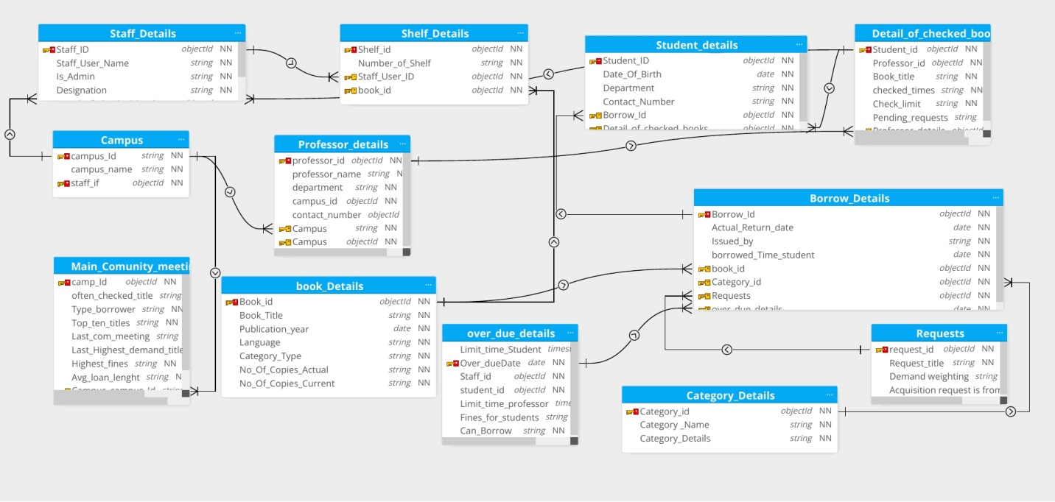

**Book_Details:**

This is the master table for all the books that are available in the Library. This table contains the complete list of books that are available in the library. Each Book id provided with a unique

**Binding:**

This column contains the Binding ID whose details can be fetched from the Binding_Detailstable. The Binding ID is a unique number given to each type of Binding.

**Category_Details:**

This includes the Category ID and Category Name. The Category ID serves as a primary key.

Columns:

**Borrower_Details:**

This table contains the details of all the persons who lent a book from the library. Each Student will be given a Unique borrower ID. All the library-related activity for a particular person will be captured based on the Borrower ID. This table will be used to track the borrowing records. The borrower ID will serve as a primary key here.

**staff_Details:**

This table contains the details of the staff in the Library. Each Staff member will be given a unique User ID which serves as a Primary Key.

**Student_Details:**

This table contains the details of all the students who are eligible for availing of Library facilities. Each student will be provided with a unique Student ID and Borrower ID. The student ID will be Primary Key, whereas Borrower_ID and Phone_no will be Unique.

**Shelf_Details:**

This table contains the position of the book…That means which floor and shelf the book is situated on.

**Professor details:**

It keeps the records of professors of different departments and campuses.

**Campus:**

It has 6 campus details and their location and id to relate to the library and the connection between them

**Main community meeting:**

Which keep the record of community meetings and books used and fines due and on which book it dues

**Requests:**

Which keeps the request detail of submitted requests on demand of people students and staff

**Detail of checked books:**

It keeps the detail of the last checked books and keeps the record of data of books to due

**Task(4) Database Tables**

**Table1: STAFF DETAILS**

create Table Staff_details (staff_id number PRIMARY KEY,

staff_user_name varchar2(50) Not null,

Is_admin varchar2(50) Not null,

Designation int);

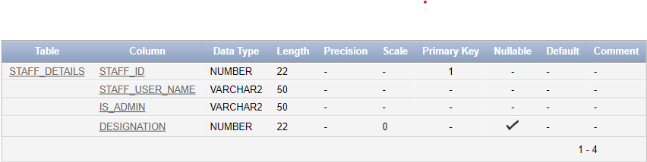

**:: their staff_id is the primary key to connecting with other tables**

**This table also contains staff names, adminship, and designation of the staff members' columns.**

**Table2: OVER DUE DETAILS**

create Table over_due_details (limit_time_students timestamp,

over_duedate date primary key,

staff_id int,

student_id int,

limit_time_professor timestamp,

fine_for_students varchar(20),

can_borrow varchar2(20));

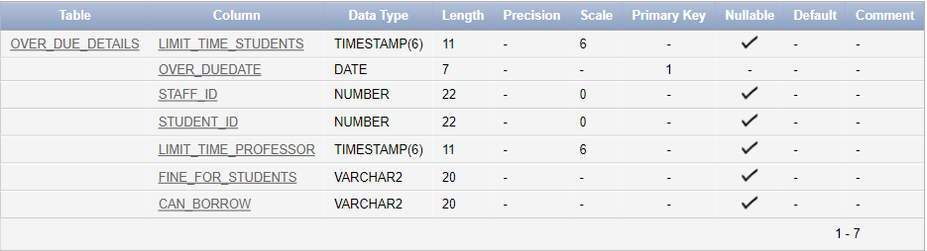

**:: their over_duedate is the primary key to connecting with other tables**

**This table also contains limit time of students, staff id, student id, limit time for professors, fine for students if they do not return or re-issue the books, and can borrow or not columns**

**Table3: BOOK DETAILS**

create Table book_details (book_id int primary key,

book_title varchar2(50),

pulisher_year int,

language varchar(50),

category_type varchar(50),

no_of_copies_actual varchar(20),

no_of_copies_current varchar2(20));

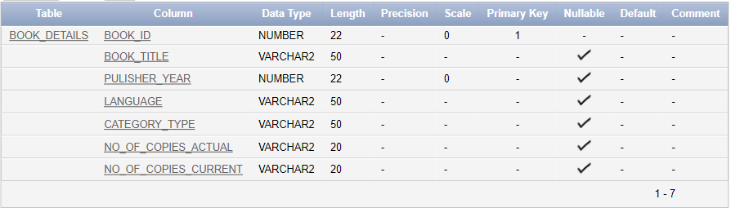

**:: their book_id is the primary key to connecting with other tables**

**This table also contain book title, publisher year, language,** **category_type , no_of_copies_actual , no_of_copies_current** **columns.**

**Table4: CATEGORY DETAILS**

create Table category_details (category_id int primary key,

category_name varchar2(50),

category_details varchar2(100));

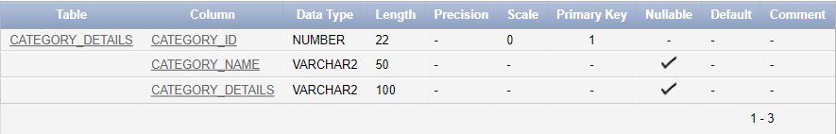

**:: their category_id is the primary key to connecting with other tables**

**This table also contains category name and category details** **columns.**

**Table5: REQUESTS**

create Table Requests (Request_id int primary key,

Request_title varchar2(50),

Demand_waiting varchar2(100),

acquisition_request_id_from varchar2(100));

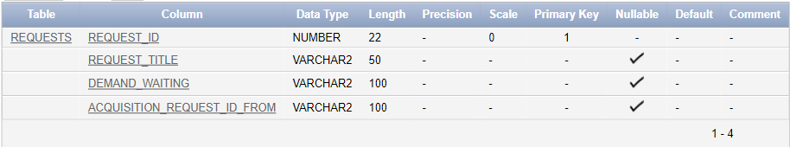

**:: their request_id is the primary key to connecting with other tables**

**This table also contains request title demand waiting and acquisition request-id columns.**

**Table6: SHELF DETAILS**

create Table Shelf_details (shelf_id int primary key,

number_of_shelf varchar2(50),

Staff_id number,

book_id int,

foreign key(staff_id) references staff_details(staff_id),

foreign key(book_id) references book_details(book_id));

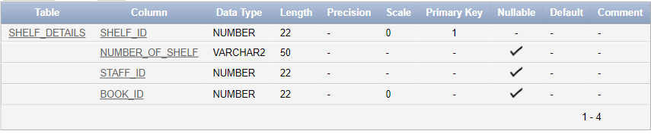

**:: their shelf_id is the primary key to connecting with other tables**

**This table also contains the number of shelf book id and staff id columns**

**The foreign key is used on book_id to connect this table with the book_details table and the Foreign key is used on staff_id to connect this table with the staff_details table**

**Table7: CAMPUS**

create Table campus (campus_id int primary key,

campus_name varchar2(50),

Staff_id number,

foreign key(staff_id) references staff_details(staff_id));

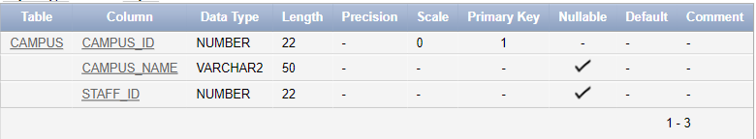

**:: their campus_id is the primary key to connecting with other tables**

**This table also contains the number of campus name and staff id columns**

**The foreign key is used on staff_id to connect this table with the staff_details table.**

**Table8: MAIN COMMUNITY MEETING**

create Table main_comunity_meeting (campus_id int,

often_checked_title varchar2(50),

type_borrower varchar2(50),

top_ten_titles varchar2(50),

last_com_meeting varchar2(50),

last_highest_demand_title varchar2(50),

highest_fines varchar2(50),

avg_loan_length varchar2(50),

Staff_id number,

foreign key(staff_id) references staff_details(staff_id),

foreign key(campus_id) references campus(campus_id));

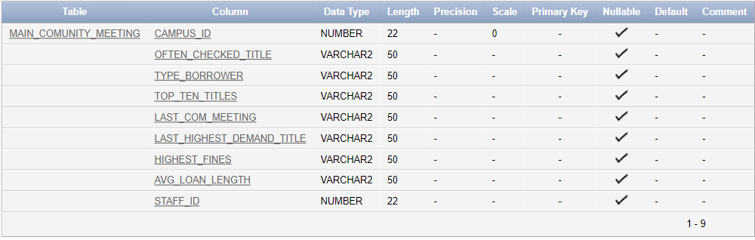

**:: This table contains campus_id, often_checked_title, type_borrower, top_ten_titles, last_com_meeting, last_highest_demand_title, highest_fines, avg_loan_length, Staff_id** **columns**

**The foreign key is used on campus_id to connect this table with the campus table and the Foreign key is used on staff_id to connect this table with the staff_details table.**

**Table9: BORROW DETAILS**

create Table borrow_details (borrow_id int primary key,

actual_return_date date,

issued_by varchar2(50),

borrowed_time_student date,

book_id int,

category_id int,

Request_id int,

over_duedate date,

foreign key(book_id) references book_details(book_id),

foreign key(category_id) references (category_id),

foreign key(request_id) references requests(request_id),

foreign key(over_duedate) references over_due_details(over_duedate));

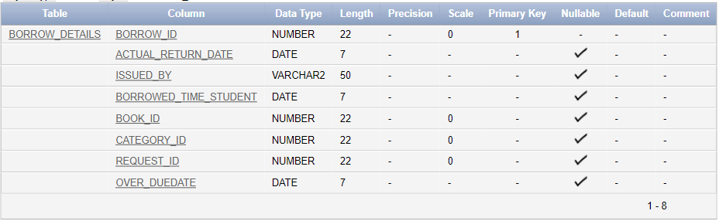

**:: their borrow_id is the primary key to connecting with other tables**

**This table also contains actual_return_date, issued_by, borrowed_time_student, book_id, category_id, Request_id, over_duedate columns**

**The foreign key is used on book_id to connect this table with the book_details table,**

**The foreign key is used on category_id to connect this table with the category_details table,**

**The foreign key is used on request_id to connect this table with the requests table and**

**The foreign key is used on over_duedate to connect this table with the over_due_details table.**

**Table10: STUDENT DETAILS**

create Table student_details (student_id int primary key,

student_name varchar2(50),

date_of_birth date,

department varchar2(50),

contact_number int,

borrow_id int,

foreign key(borrow_id) references borrow_details(borrow_id));

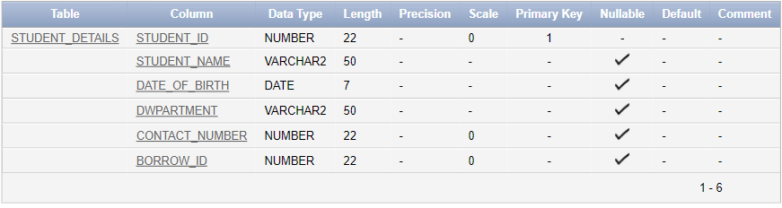

**:: their student_id is the primary key to connecting with other tables**

**This table also contains student name, date of birth, department, contact number, and borrow id columns**

**The foreign key is used on borrow_id to connect this table with the borrow_details table.**

**Table11: PROFESSOR DETAILS**

create Table professor_details (professor_id int primary key,

professor_name varchar2(100),

department varchar2(50),

campus_id int,

contact_number int,

foreign key(campus_id) references campus(campus_id));

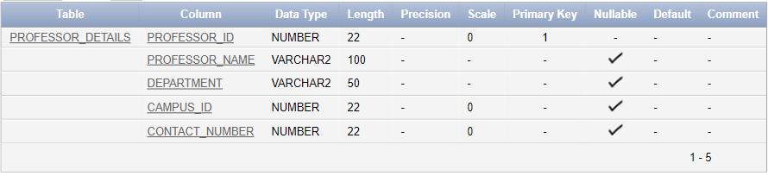

**:: their professor_id is the primary key to connecting with other tables**

**This table also contains professor name, department, campus id contact number columns**

**The foreign key is used on campus_id to connect this table with the campus table.**

**Table12: DETAILS OF CHECKED BOOKS**

create Table detail_of_checked_books (student_id int,

professor_id int,

book_title varchar2(100),

checked_time varchar(20),

checked_limit varchar(20),

pending_requests varchar(20),

foreign key(student_id) references student_details(student_id),

foreign key(professor_id) references professor_details(professor_id));

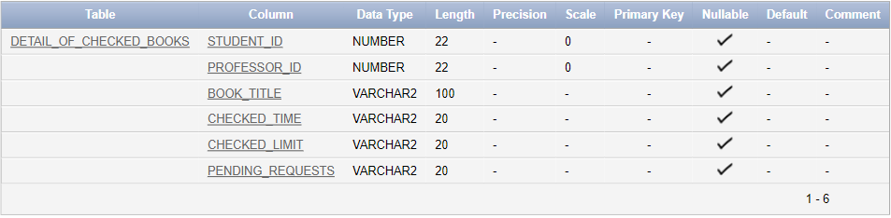

**:: This table contains student id, professor id, book title, checked time, checked limit, and pending requests columns**

**The foreign key is used on student_id to connect this table with the student_details table**

**And Foreign key is used on professor_id to connect this table with the professor_details table.**

# References

Software 1 ; moon modeler by Datensen .

Software 2 ; 11g by oracle